**Assignment 1**

**Abdullah Khalid (21-11214)**

**Test Report**

One program was written on which the different test cases were run. In the screenshot below, the code has been shared. Four mini programs have been added to this code. The first one calculates volume of square, the second one calculates volume of sphere, the third one calculates volume of cylinder and the fourth mini program converts radians to degrees.

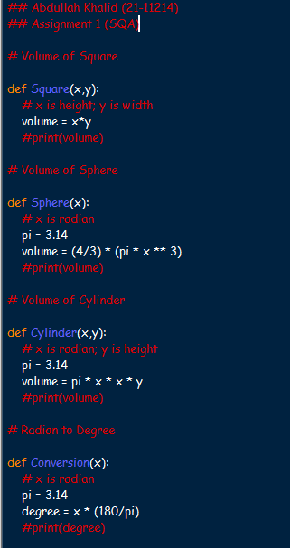

**Test Case # 1:**

The screenshot is shown below:

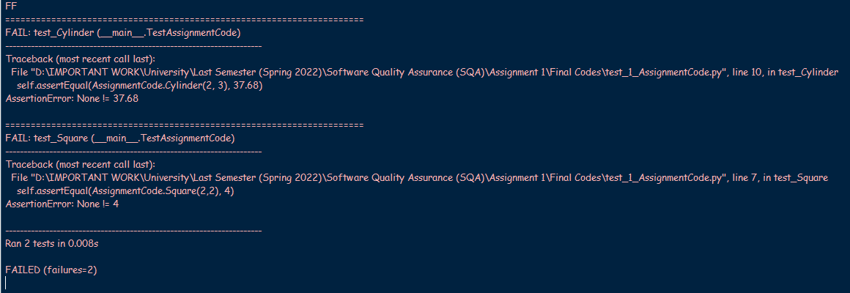

**Test Case # 2:**

The screenshot is shown below:

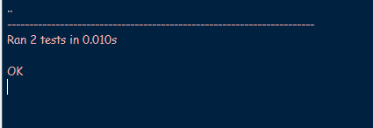

**Test Case # 3:**

The screenshot is shown below:

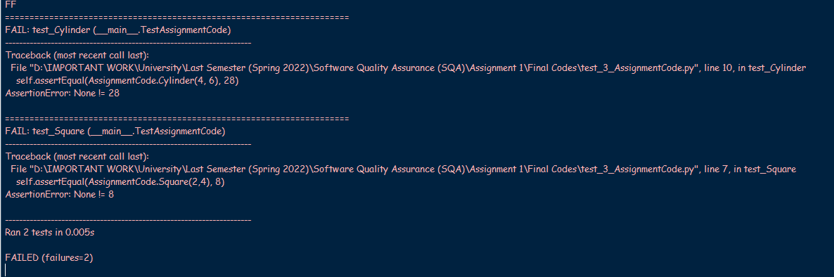

**Test Case # 4:**

The screenshot is shown below:

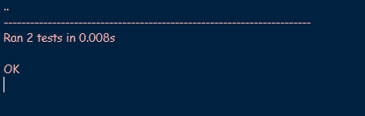

**Test Case # 5:**

The screenshot is shown below:

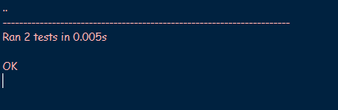

**Test Suite:**

The screenshot is shown below:

